|  |  |  |  |  |  |  |  |  |  |  |  |  |  |  |  |  |  |  |
| --- | --- | --- | --- | --- | --- | --- | --- | --- | --- | --- | --- | --- | --- | --- | --- | --- | --- | --- |
|  |  | Lab Book  Program Design  DT2XX-1  Firstname Surname  Ronan Dillon   |  |  | | --- | --- | | *Date :* |  | | *Last Lab* |  | |  |  | | *Version:* | *3* | | *Status:* | *Draft / Release* | |  |  | |  |  | |  |  | |

Document Control

|  |  |  |
| --- | --- | --- |
| Contributors | | |
| **Name/Position** | **Organization** | **Contact Details** |
|  |  |  |
|  |  |  |

|  |  |  |  |
| --- | --- | --- | --- |
| Version History | | | |
| **Date** | **Version** | **Status** | **Comments** |
|  |  |  |  |
|  |  |  |  |
|  |  |  |  |

|  |
| --- |
| Changes since last version |
|  |

|  |
| --- |
| Known Omissions |
|  |

Table of Contents

1 Lab 01 : My CV……………………………………………………………………………………………………………………….…………4

1.1 Who am I………………………………………………………………………………………………………………………………………..4

1.2 Have you have done any programming before and if so, in what language and what did you build.…4

1.3 Why are you doing computer science, what is your interest in programming…………………………..……..4

1.4 What is your favourite Website, App and software – Why?.................................................................4

1.5 What piece of software, app or website do you wish you had created or would like to create?..........4

1.6 Your hobbies and interests……………………………………………………………………………………………………………..4

1.7 An interesting fact about you………………………………………………………………………………………………..………4

2 Lab 01: Transport Puzzles…………………………………………………………………………………………………..………5

2.1 Definition of the problem………………………………………………………………………………………………………..…….5

2.2 Approach……………………………………………………………………………………………………………………………………….5

2.3 Results…………………………………………………………………………………………………………………………………………..5

2.4 Definition of the problem………………………………………………………………………………………………………………6

2.5 Approach……………………………………………………………………………………………………………………………………….6

2.6 Results…………………………………………………………………………………………………………………………………………..6

3 Lab02 : Algorithm #1…………………………………………………………………………………………………………………….7

4 Lab02 : Algorithm #2…………………………………………………………………………………………………………………….8

**5** **LAB03: FLOWCHART #1……………………………………………………………………………..………………………………………9**

**6**  **LAB03: FLOWCHART #2………………………………………………………………………….…..……………………………………10**

**7** **LAB03: FLOWCHART #3………………………………………………………………………….…..……………………………………11**

**8** **LAB03: FLOWCHART #4……………………………………………………………………………...……………………………………12**

**9** **LAB03: FLOWCHART #5……………………………………………………………………………………………………………………13**

**10** **LAB03: FLOWCHART #6…………………………………….……………………………………..…………………….……………….14**

**11 LAB04: GENERAL PROBLEM……………………………………………………………………………………………………….……15**

**12 LAB04: FLOWCHART OF GENERALPROBLEM #1……………………………………………………………………………….16**

**13 LAB04: FLOWCHART OF GENERALPROBLEM #2…………………………………………………………………………………17**

# Lab 01 : My CV

## Who am I

Name: Ronan Dillon

Photo

## Have you have done any programming before and if so, in what language and what did you build

No I have not done anything

## Why are you doing computer science, what is your interest in programming

Honestly, for the possibility of good jobs

## What is your favourite Website, App and software – Why?

Twitter. Its great craic following famous people

## What piece of software, app or website do you wish you had created or would like to create?

The iphone because I can’t afford one so a free one for making it would be cool

## Your hobbies and interests

Football

## An interesting fact about you

I was in the music video for Ireland’s euro 2012 song

# Lab 01: Transport Puzzles

## Definition of the problem

A farmer is on one side of a river. With him is a fox, a goose and a bag of beans. The farmer wants to transport the fox, goose and bag of beans to the other side of the river. There is a boat in the river that he can use to transport them across. The boat can only hold the farmer and one other of the other three. The farmer must be on every crossing as he is needed to steer the boat. If left alone the goose will eat the beans and the fox will eat the goose. How can the farmer get all of them across intact?

## Approach

|  |  |  |
| --- | --- | --- |
| Starting Side | Action | Ending Side |
| Farmer, Fox, Goose, Beans |  |  |
| Fox, Beans | The farmer takes the goose across | Farmer, Goose |
| Fox, Beans, Farmer | The farmer returns alone | Goose |
| Fox | The farmer takes the beans across | Goose, Farmer, Beans |
| Fox, Farmer, Goose | The farmer takes the goose back | Beans |
| Goose | The farmer takes the fox across | Beans, Farmer, Fox |
| Goose, Farmer | The farmer returns alone | Beans, Fox |
|  | The farmer takes the goose across | Beans, Fox, Farmer, Goose |

## Results

In doing this algorithm the farmer succeeds in getting the fox, goose, and the bag of beans across the river without anything being eaten.

## Definition of the problem

There are six animals on one side of a river a dog, two cats and three baby chicks. You want to transport these animals to the other side of the river. You are controlling the boat. You can take two animals each time you cross however there are some conditions. You can’t leave the dog on the same side as one of the cats as there will be a fight and the number of chicks on each side must outnumber the cats on that side.

## 2.5 Approach

|  |  |  |
| --- | --- | --- |
| **Starting Side** | **Action** | **Ending Side** |
| Dog, Cat1, Cat2, Chick1, Chick2 ,Chick3 |  |  |
| Dog, Chick1, Chick2, Chick3 | Bring the two cats across | Cat1, Cat2 |
| Chick2, Chick3 | Bring the Dog and Chick1 across | Dog, Chick1, Cat1, Cat2 |
| Chic2, chick3,Cat1, Cat2 | Bring the two cats back | Dog,Chick1 |
| Cat1,Cat2 | Bring Chick2 and Chick3 across | Dog, Chick1, Chick2, Chick3 |
|  | Bring Cat1 and Cat2 across | Dog, Chick1, Chick2, Chick3, Cat1, Cat2 |

## Results

You have got all the animals across to the other side. No animal was harmed in the crossing of this river.

# Lab02 : Algorithm #1

|  |
| --- |
| For the picture of a kite write a set of instructions that work!  Ensure only *one* way to interpret each step  *unambiguous*  … and enough detail in each step  About 10 steps |
| **A Good Algorithm:**   1. Draw a straight line vertical in the centre of the page 2. Draw a horizontal line which intersects the vertical line at its midpoint (the horizontal line should be about half the length of the vertical line 3. Draw a diagonal line from the top of the vertical line to the left point of the horizontal line 4. Draw a diagonal line from the top of the straight line to the right point of the horizontal line 5. Draw a diagonal line from the bottom of the vertical line to the left point of the horizontal line 6. Draw a diagonal line from the bottom of the vertical line to the right point of the horizontal line 7. Draw a curved line from the bottom of the vertical line 8. You should end up with a kite |

# Lab02 : Algorithm #2

|  |
| --- |
| 1. **Draw a shape on paper, but not a HOUSE or a PLANE, too obvious!** 2. **Write the *algorithm***   **Write a set of instructions that explains how to make a paper shape from 1 sheet of A4 paper**   1. **Test it**   **Try out your algorithm with someone else – does it work?**  **Note: follow your instructions *as closely as possible***   1. **Adjust the instructions if necessary** |
| **Your Algorithm:**   1. Get an A1 piece of paper 2. Draw a 5 centimetre line on middle of the right hand side of the page 3. Draw a 5 centimetre line south west of the top point of your first line 4. Draw another line connecting the two lines 5. Draw an oval 15 centimetres in length touching the west corner of the triangle 6. Draw a 1 centimetre radius circle 2 centimetres in from the west side of the circle 7. At the top of the oval draw a triangle with lines of 3 centimetres 8. Draw a 5 centimetre curved line 5 centimetres east of the circle 9. Draw another 5 centimetre curved line 2 centimetres east of the first curved line 10. Draw a final curved line 2 centimetres east of the second curved line 11. You should have a fish |
| **Draw the paper shape your algorithm would produce:** |

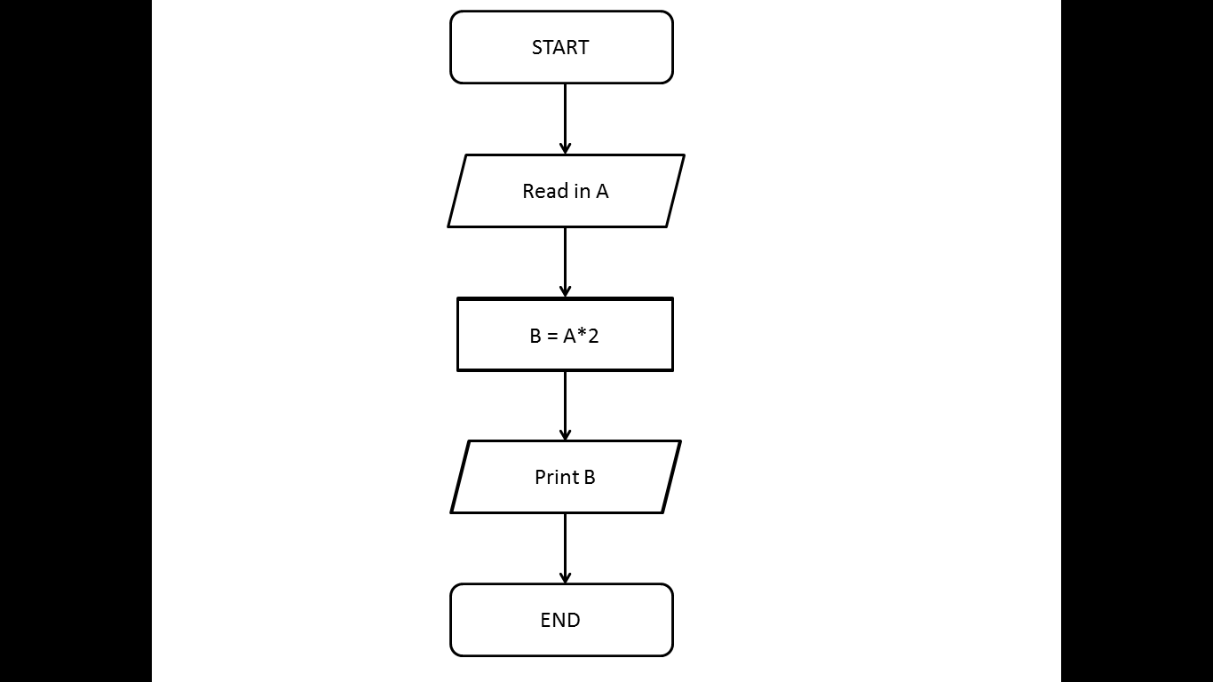

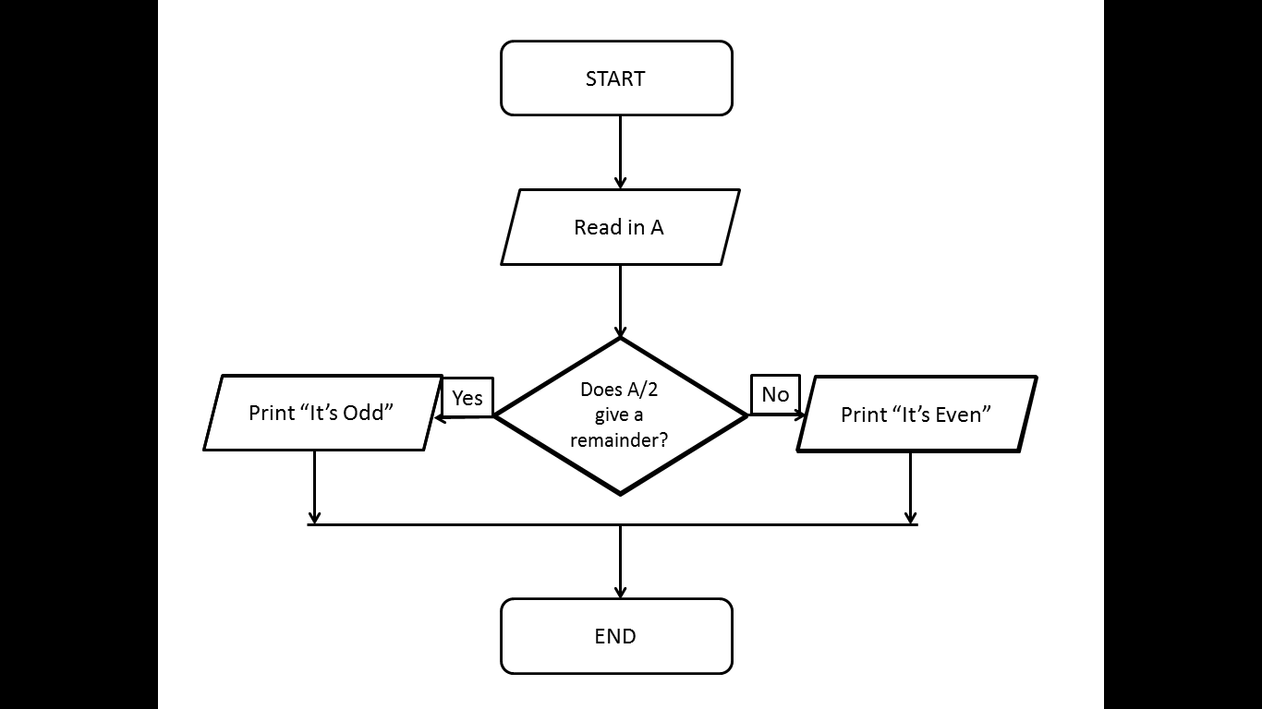

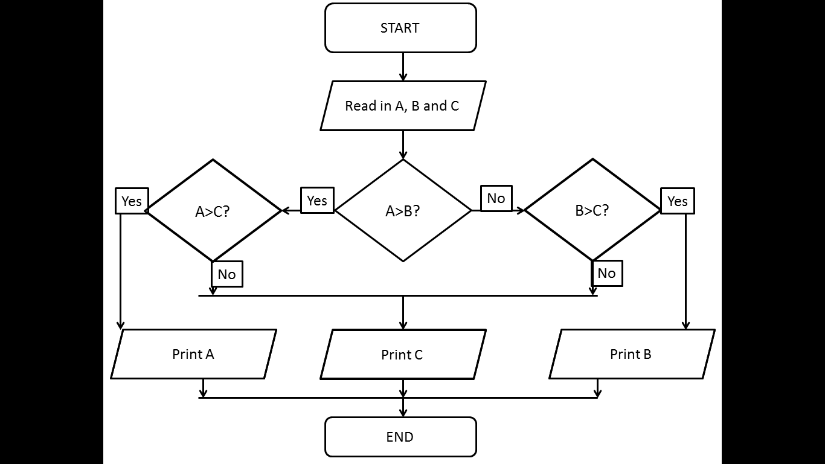

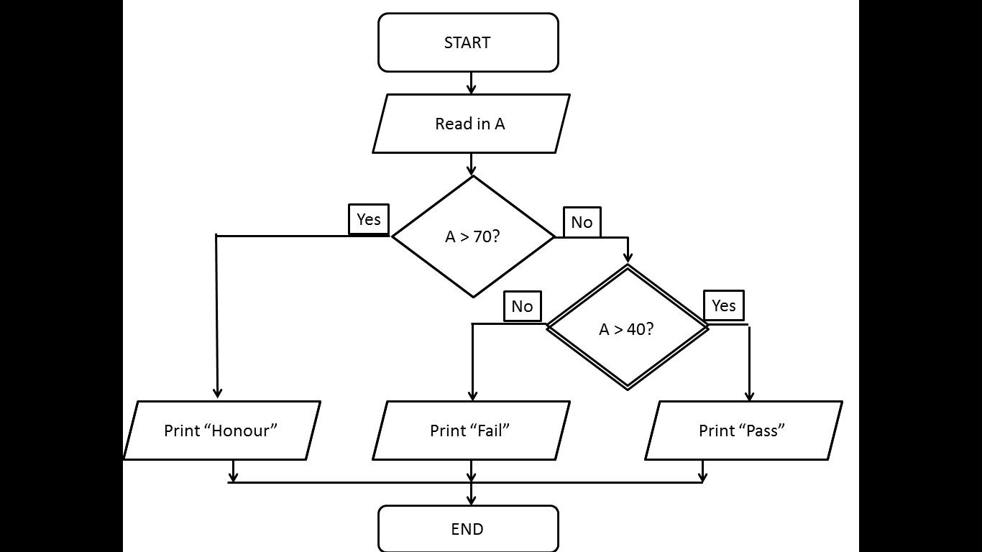

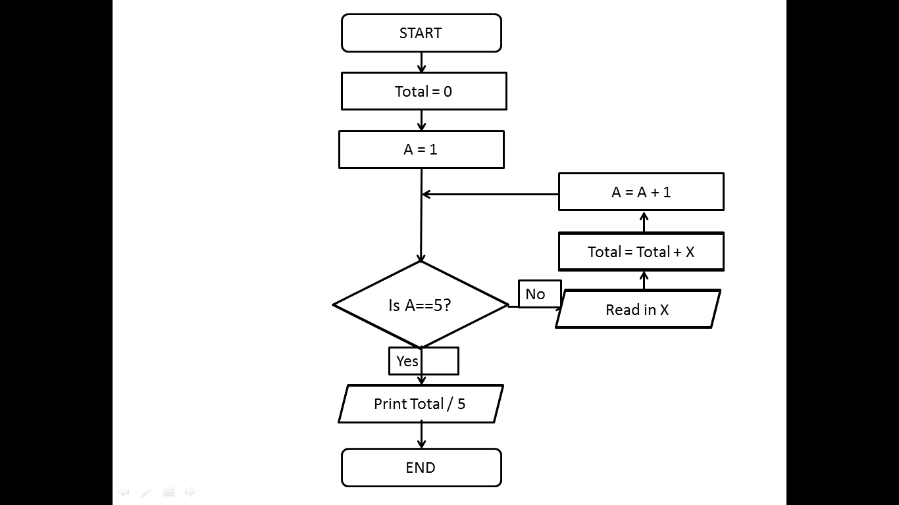

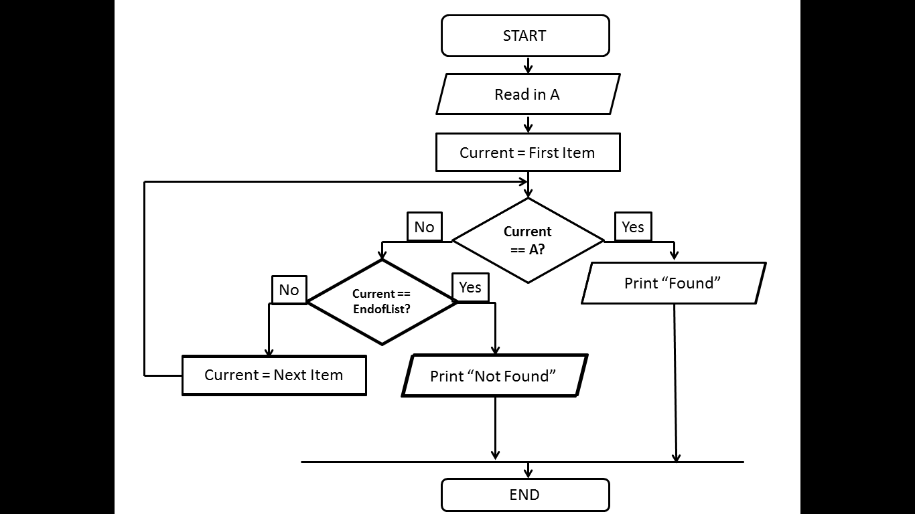

## Definition of the problem

Two armies are on the outskirts of an enemy city. The two generals of the army want to communicate with each other so they can agree on a time to attack the enemy army. The only way they can defeat the enemy army is if both armies attack at the same time. There are three possible scenarios that could take place 1) General one could send the message to attack at noon but the message is intercepted and general two does not receive it so general one and his army attack but general two and his army don’t so they will be defeated. 2) General one could send the message to attack at noon and general two receives it. General two sends a message back to say he will attack at noon too but it is intercepted and general one does not receive it so he does not send his army to attack. Army two attacks and is defeated. 3) Both generals send their messages without being intercepted and both armies attack at noon defeating the army.

How can both generals communicate effectively without being their messages being intercepted?

## Approach

The five ways that my group came up with so that the two generals can communicate effectively without their communications being intercepted are

1. Get a phone and call the other general
2. Start a private event of facebook that only the other general can see that has details of the time and place of attack.
3. Send more than one messenger with the message
4. Get a messenger to walk around the enemy city with the message
5. Set off 12 fireworks to signal the attack to be at noon

## Critique of Ideas

1. Mobile phones can easily be tapped so the enemy can hear the details of the attack time
2. Facebook Is not a very secure way of communication as it is easy to hack into accounts which would mean that the event could be seen by the enemy
3. Sending more than one messenger increases the chances of the message getting through but it also increases the chances of the message being intercepted which would let the enemy know the time of the attack
4. Walking round the city may take a long time, time which the armies may not have so this would not be effective.
5. This could easily be understood by the enemy and they could set off more fireworks to confuse the other army

**Members of my group:** Ronan Dillon, Carl MacDiarmada, Mark Naylor

